**Assignment 1  
-Developing a Web Page 1 (100 points)-**

**Important: Students are supposed to do all the exercises in the Module 1, prior to try this Assignment.**

**Assignment Submission Rules:**

1. **Detection of plagiarism will result in receiving the failing grade.**
2. **After completion, students must submit the following three types of deliverables through D2L assignment box (previously Dropbox) by the deadline:**
   1. **Your CODE (“.html”, “.css”, and “.js”) must be submitted in files separate from the report, so that I can compile and run it in my environment. It is better submitting a compressed project folder. Each function, method, class, and variable should be identified and their functions explained in comments.**
   2. **Your CODE in document type: All of your implementation must be converted into any of three format: “.txt”, “.doc or .docx”, or “.pdf”. You can simply copy and paste your CODE on “notepad” or “MS word”. The converted files must not be compressed and must be submitted separately.**
   3. **A REPORT FILE (MS word or pdf): This text file should include i) A description of your solution; and ii) the output displayed when running your code. Your solutions description should include a synopsis of how your code is intended to work and the tests that you created to prove that it works as intended. The output can be a screen-shot from your computer.**
   4. **Failure to follow the rules will result in deducting points.**
3. **It is much better to submit a partial/failed-attempt solution than none. Include the circumstances of the incompletion in your report.**

**Problems:**

Develop your personal web page. You can search and refer any style of webpages from the Internet. However, it does not allow getting any codes, which means your web page must be implemented by yourself.

Minimum requirements that must be satisfied can be described as follows:

* At least four different sections (design your own web page) – 40 points
* Your photo and descriptions about you – 30 points
* At least 5 buttons linked to another resources (for the further assignments) - 30 points

**Basic screen with simple styling (Sample)**

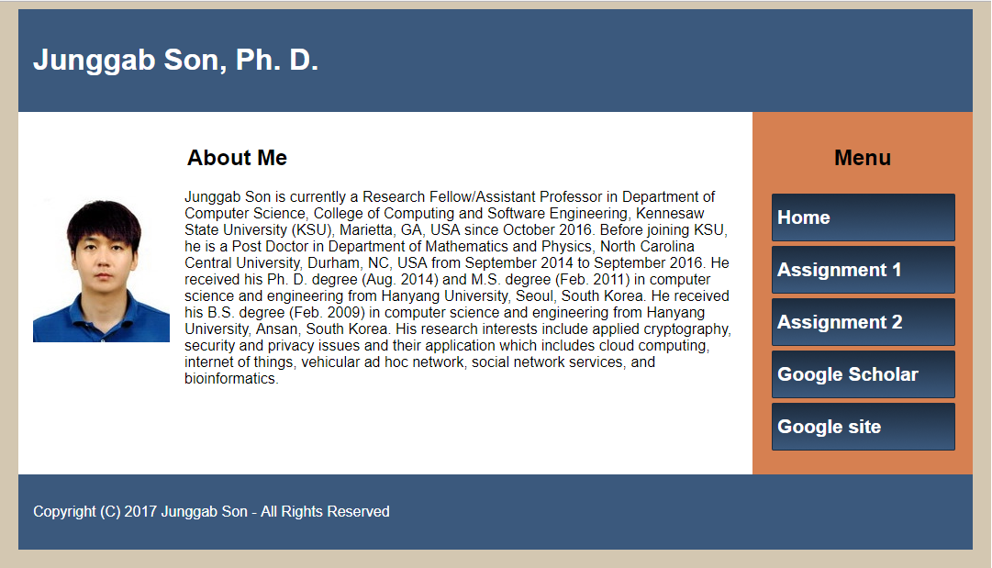

**Testing**

Your application will be either tested from your project directory or the files will be copied to another directory. Use relative paths to link parts of the application together.